**🪲 Bug Report**

* **Title**: User can proceed to checkout with an empty cart- no error message is shown
* **ID**: BUG-001
* **Severity**: Low
* **Priority**: Low
* **Environment**:
  + OS: macOS Sequoia 15.3.1
  + Browser: Chrome 122 / Playwright headless
  + App URL: [https://www.saucedemo.com/](https://www.saucedemo.com/" \t "_new)
  + Test Env: Automation test using Playwright

**📋 Precondition**:

User is in the inventory page.

The cart is empty

**🧪 Steps to Reproduce**:

1. Open the login page
2. Enter username: standard\_user
3. Enter password: secret\_sauce
4. Click the Login button
5. Click the cart icon
6. Make sure the cart is empty
7. Click “check out”

**✅ Expected Result**:  
User is not redirected and an error message shows saying “Error: Cart is empty”.

**❌ Actual Result**:  
User is redirected to “checkout-step-one” in order to fill his details (as shown in screenshot).

**📷 Screenshot / Evidence**:  
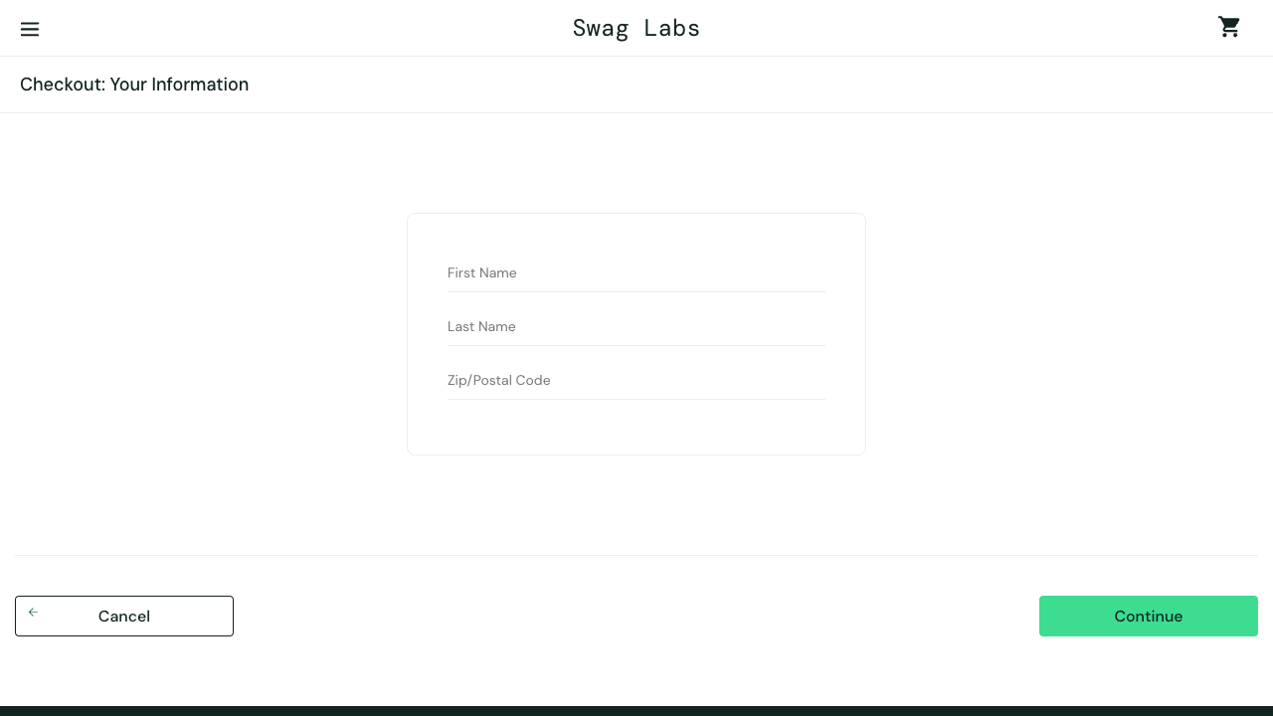

**💬 Additional Notes**:

* This issue occurs consistently on headless mode and UI mode.
* DOM locator used:
* this.cartIsEmptyErrorSelector = page.locator('h3', {hasText: "Error: Cart is empty"});
* Possible root cause: No check is being conducted to verify there are products in the cart.

**🔁 Suggested Fix / Developer Hint**:

* Check the number of products in the cart on check out